Communicable Disease
Emergency Response Plan
INSERT COMMUNITY NAME
Contents
When & How to Use Communicable Disease Emergency Response Plan 3
CDE SITUATION AND RESPONSE 5
Roles & Responsibilities 6
EOC Roles, Responsibilities & Contact Information 6
Stakeholders Roles & Responsibilities 9
CONTINUITY OF ESSENTIAL SERVICES 11
Communication Plan 12
Examples of Public Health Management 13
Testing Procedures 13
Contact Tracing & Case Monitoring 13
Transporting Clients 14
Vaccine Plan 15
Community Member Supports 16
Care & Protection of Elders & Vulnerable Community Members 16
Food Security 16
Self-Monitoring 16
Self-Isolation 16
Accommodation 17
Emergency Financial Support 17
Education Support 17
Child, Youth & Family Support 17
Traditional Healing/Cultural Wellness 17
Mental Health 18
Substance Support 18
For the Deceased; Grieving & Loss Considerations 18
RECOVERY 19
APPENDIX 1: PRIORITY COMMUNITY MEMBERS LIST 21
APPENDIX 2: EMERGENCY OPERATION CENTRE 22
APPENDIX 3: LESSONS LEARNED 23
APPENDIX 4: DOCUMENT WEB LINKS 24

When & How to Use Communicable Disease Emergency Response Plan

A Communicable Disease Emergency Response Plan (CDER Plan) should be created and used by communities to prepare for and respond to a disease outbreak, such as a pandemic or epidemic as declared by the province or federal government.
This plan would not be used for single cases of a communicable disease, which are are better handled by the Regional Health Authority for management and guidance.
Communities wishing to create a CDER Plan should create a team and assign people to different sections based on their skills and expertise in community planning. There may be funding available to support the creation of your CDER Plan. Please reach out to the CD management team (cdmgmt@fnha.ca) for more information.
An Emergency Operations Centre/Committee (EOC) is a formal organization structure that is activated to support a response, including a disease response, and is adjusted continuously to adapt to meet rapidly changing demands of the situation. An EOC is typically disbanded at the end of the emergency or when the situation no longer requires a command structure to respond to the situation. An EOC has the ability to support communities through communicable disease emergencies by implementing support measures, assisting with communication and ensuring public health guidelines are followed. Roles and Responsibilities for this structure are listed below, along with supporting documents.

INSERT INFORMATION is/are responsible for developing the community CDE Response Plan. The plan will be reviewed annually by INSERT INFORMATION.

Changes to the plan will be made as required, which will include updating staff changes, Internet links and resources, and contact information.

The revised plan will be submitted to INSERT INFORMATION (i.e., Chief and council/CDE Planning Committee/Health Director) for administrative approval.

After the plan is revised and approved it will be shared with all staff, community partners, and the FNHA Communicable Disease Management team (cdmgmt@fnha.ca).

ACRONYMS IN THIS DOCUMENT

BCCDC BC Centre for Disease Control
CD(E) Communicable Disease (Emergency)
EOC Emergency Operations Centre
(H)EMBC (Health) Emergency Management BC
IPC Infection Prevention and Control
MHO Ministry of Health
PPE Personal Protective Equipment
RHA Regional Health Authority
PHSA Province Health Services Authority

CDE SITUATION AND RESPONSE
Stage of CDE | Critical Functions | Key Players
ROUTINE  (Before a CDE event occurs in your community) | The community is operating under normal conditions.  - Normal business hours, processes and capacity/structure  - Normal infection prevention and control measures for ongoing communicable disease  - Check PPE stock and expiry dates, order if needed (not all diseases require N95 respirators) http://www.bccdc.ca/Health-Professionals-Site/Documents/AGMPs_requiring_N95.pdf (COVID-19 Specific)  - Employers are required to ensure all staff mandated to use a medical N95 respirator for their job and are properly fit-tested annually  - Monitor BCCDC and Public Health updates to determine characteristics of disease, screening and assessment tools, testing (start communication early)  - Create communication tools about public health measures if needed | - Health Representative  - Risk Management/Safety  - RHA or FNHA to supply updates
ENHANCED  (A CDE event is occurring or impending) | The community is moving into response mode due to communicable disease cases in or near community.  - The incident will require enhanced planning and/or operations  - Consider activation of the CDE response plan  - Escalated and additional infection prevention and control measures  - Organize supports as appropriate to disease specific requirements  - Education, planning and communication surrounding the CDE and how to keep community members and staff safe | - EOC Director/Incident Commander  - Health Representative  - Communication  - RHA Contact  - Leadership
INCIDENT/ EMERGENCY  (A CDE event is occurring on a larger scale) | The community is moving into incident/emergency mode due to multiple cases in community.  - Within the community, a communicable disease emergency is occurring that requires a larger, coordinated organizational response effort  - Community may declare a local state of emergency  - Follow infection prevention and control measures and public health guidelines  - Community implements and/or connects members to enhanced supports (i.e., food security, mental health supports, additional support for priority/vulnerable community members)  - Refer to EOC roles and responsibilities | - EOC Director/Incident Commander  - Health Representative  - Communication  - Leadership  - Operations, planning, logistics, finance
RECOVERY  (A CDE event is over or has stabilized) | The community is moving into recovery as cases have declined to the point that services can resume.  - Local impact of the CDE has diminished to a level where normal services may be resumed and the community, along with its partners/stakeholders, is working to ensure a smooth transition back to routine conditions  - Hold a review and debriefing (lessons learned)  - Use learnings to update CDE response plan | - EOC Director/Incident Commander  - Communication  - Leadership

Roles & Responsibilities
Each member is responsible for delegating a backup contact in the event of absence.
Complete this table below, review and adjust the roles and responsibilities to fit your community

EOC Roles, Responsibilities & Contact Information

TEAM MEMBER | PRIMARY CONTACT
EOC Director  - Overall responsibility for activation, co-ordination and eventual disbanding of EOC  - Activate: due to confirmed cases in community during a pandemic or epidemic  - When the community feels they can no longer manage cases or there is concern of rapid spread, clusters or outbreaks.  - Inform necessary stakeholders of plan activation.  - Deactivate during recovery phase.  - Overall responsibility to ensure effective implementation of CDE Response Plan  - Provide leadership to management and staff teams  - Approve response objectives and priorities  - Ensure sufficient support, policy advice and resources are made available to accomplish priorities  - Ensure engagement with public health and CD expertise to provide the context and guide effective response measures  - Work with the incident commander to assess immediate and long-term impacts and consequences | Name:  Phone:  Email:
Incident commander  - Assume role of EOC director in their absence  - Undertake special assignments at the request of the EOC director  and/or incident commander  - In charge of tactical, on scene operations  - Ensure efficient and effective flow of information within the EOC  - Set up communication pathway/channels, train team members how to communicate (weekly meetings, minutes, send out updates)  - Ensure resource requests are prioritized and tracked | Name:  Phone:  Email:
Elders, Chief and Council  - Review CDE plan  - Review final communication | Name:  Phone:  Email:
Health Representative  - Provide direct input to the incident commander on unique aspects of communicable disease emergencies  - Establish communication links with the RHA, the FNHA and other Health Agencies (Public Health Agency of Canada, BCCDC)  - Provide advice on public health matters for isolation guidelines, infection and prevention, transportation, vaccines/antiviral etc. from information gathered from RHA, FNHA CD experts and IPC experts, BCCDC and Public Health Agency of Canada  - Liaise with agencies listed about developing testing guidelines, vaccine plan when applicable  - Liaise between EOC logistics and Community Health Services to determine needs such as counting PPE, checking expiry dates, ordering supplies  - Provide authoritative instruction on health and safety matters to the community through the information officer | Name:  Phone:  Email:
Risk Management/Safety  - In consultation with the health representative, ensure appropriate risk management measures are instituted  - Oversee and implement safety recommendations for all employees  - Oversee and implement infection prevention and control recommendations to prevent the spread of infections during service delivery to both staff and clients  - Liaise with FNHA Infection Prevention & Control for support (ipc@fnha.ca)  - Liaise with Health Representative and others to determine safe procedures and areas for testing, vaccination etc. | Name:  Phone:  Email:
Community Liaison  - Along with the health representative, act as point of contact for, and interaction with, representative from other agencies  (e.g., local EOCs)  - Work with the incident commander and EOC director to prepare reports as needed | Name:  Phone:  Email:
Communication Officer  - Represent the community at EOC meetings and in EOC decision-making process  - Engage in direct communications to community members  - Collaborate with department leads to create a concise and uniform message  - Conduct media interviews | Name:  Phone:  Email:
Information Officer  - Serve as the coordination point for all community/stakeholder information, media relations and internal information sources  - Collect and validate information  - Ensure community/staff receive complete, accurate and consistent information about public health advisories, relief and assistance programs and other vital information  - Ensure organization has the capacity to receive and address community/staff/stakeholder inquiries/take minutes at meetings & send out updates | Name:  Phone:  Email:
Provincial Regional Emergency Operations Centre (PREOC) Contact/Source  - Liaise with EOC Director and Incident Commander to offer support | Name:  Phone:  Email:
Operations - “the doers”  - Ensure daily essential services are provided and that operational objectives and assignments identified in the EOC Action Plan are carried out effectively  - Direct operations and ensure safety of staff  - Designate branch coordinators as necessary  - Liaise with health and others to determine safe procedures and areas for testing, vaccination, etc.  - Organize volunteers for transporting clients  - Liaise with health to ensure PPE and infection control guidelines are in place  - Functional branches include  - Health  - Emergency social services  - Community support | Name:  Phone:  Email:
Planning Section - “the thinkers”  - Responsibility is to collect, evaluate and disseminate information; develop the jurisdiction’s Action Plan in coordination with other functions; maintains documentation.  - Assess impacts  - Create priority lists  - Prepare to support long-term recovery  - Collect and evaluate information  - Develop incident action plans  - Maintain resource status (personnel, equipment)  - Maintain incident documentation | Name:  Phone:  Email:
Logistics Section - “the getters”  - Ensure resource support for the implementation of the initial and  ongoing response (personnel, supplies, equipment, transportation, isolation supports)  - Section functions include:  - Stockpile/inventory control and distribution  - EOC support (facility, security)  - Information technology  - Public works | Name:  Phone:  Email:
Finance/Admin - “the payers”  - Track all costs pertaining to the CDE response, apply for reimbursement funding where/when applicable  - Section functions include:  - Time recording  - Procurement  - Compensation and claims  - Cost accounting | Name:  Phone:  Email:

Stakeholders Roles & Responsibilities
Regional Health Authority  - Regional MHO has the legal responsibility to manage communicable disease under the Public Health Act 2009  - Establish methods for accessing/collecting, reporting, analyzing and sharing data related to CD;  - Deliver services including immunization programs, harm reduction, and screening;  - Manage and control CD outbreaks including individual case management and partner/contact notification; and emergency management of large-scale communicable disease outbreaks;  - Develop strategies for public education and awareness, advocacy for healthy public policies and community development. | Name:  Phone:  Email:
Provincial Contacts  - Ministry of Health and Provincial Health Officer supports First Nations communities and Indigenous peoples by providing updates, documents and expertise to the public and communities;  - BCCDC works with provincial and federal partners on surveillance, diagnostic testing and infection control measures during a CDE;  - EMBC is the lead coordinating agency for non-medical emergency response hosting regular coordination calls and acting as a universal entry to First Nations communities seeking support;  - PHSA coordinates with HEMBC to activate a Health Emergency Coordination Centre for coordinating partners responding to CDEs;  - PHSA provides and shares information about vaccines and assists regional health authorities with procuring personal protective equipment and medical supplies.  - FNHA facilitates communities’ response to CDE, access to personal protective equipment during a CDE; and ensuring that First Nations priorities are reflected in overall CDE planning at all levels of government. | Ministry of Health & Provincial Health Officer | Name:  Phone:  Email:
 | EMBC | Name:  Phone:  Email:
 | PHSA | Name:  Phone:  Email:
 | HEMBC | Name:  Phone:  Email:
 | FNHA | Name:  Phone:  Email:
First responders  (e.g., fire, BC ambulance, coast guard)  - Liaise with EOC and offer support | Police | Name:  Phone:  Email:
 | Fire | Name:  Phone:  Email:
 | Ambulance | Name:  Phone:  Email:
Volunteer Coordinator Cultural Support  - Support community members directly impacted by the communicable disease emergency. | Name:  Phone:  Email:

CONTINUITY OF ESSENTIAL SERVICES

Your community’s Business Continuity Plan can help your community identify and maintain critical services during an incident when people and resources may be diverted. This plan also helps your community re-establish full functions as quickly as possible following an incident.
In the event of a CDE, your community may need to limit the programs and services it provides. This decision may need to be re-evaluated on an ongoing basis as the CDE progresses.
What is essential in your community? What can be moved online or virtual? What is the minimum personnel required? Are staff members cross-trained (i.e., able to do other jobs as the need arises)? How long can your community go without this service? Is there a backup?

Please customize the following table to reflect your community
Critical Functions of Each Department
DEPARTMENT | Department Manager/Lead | CRITICAL FUNCTIONS/SERVICES
Health | Name:  Phone Number:  Email:
Education | Name:  Phone Number:  Email:
Social Development | Name:  Phone Number:  Email:
Wellness & Recreation | Name:  Phone Number:  Email:
Natural Resources | Name:  Phone Number:  Email:
Grocery Store | Name:  Phone Number:  Email:
Gas Station | Name:  Phone Number:  Email:
Band Office/Admin | Name:  Phone Number:  Email:

Communication Plan

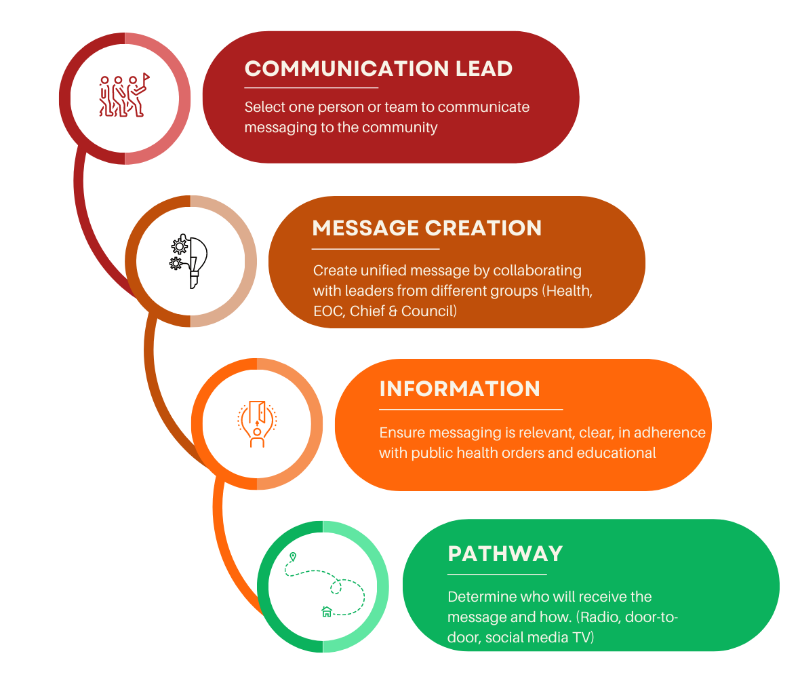

- Consider storing all communications from a communicable disease emergency in one place to use/reflect on during debriefing sessions.

Examples of Public Health Management

Testing Procedures:
Refer to the BCCDC website for disease specific testing procedures. If your community can support in-community testing, collaborate with the RHA to create a testing community specific pathway. Share information to community members when and how to access testing.
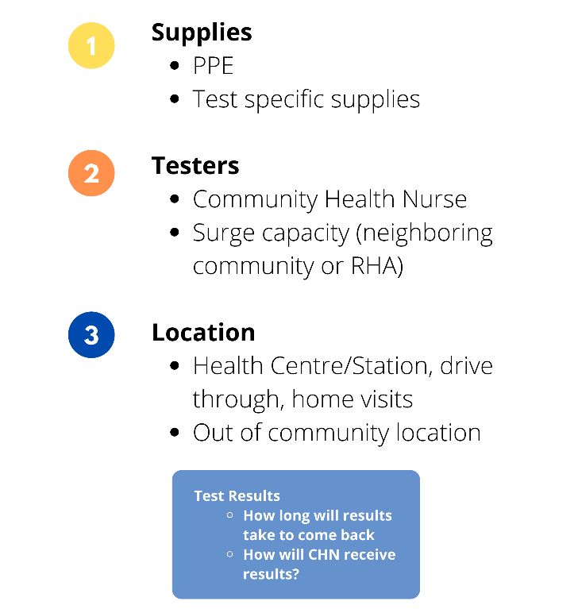

Contact Tracing & Case Monitoring:
Contact tracing is the responsibility of the Regional Health Authority (RHA) who may ask a nurse in the community to support this task. The RHA communicable disease team/contact tracers will provide guidance on:
- Who requires contact tracing follow-up/ case management recommendations from RHA
- Who should be tested (i.e. contacts with symptoms will be referred for testing)
- How often follow-up should occur
- Instructions on how to reduce transmission and care for self (i.e. self-isolation, hand washing)
- What symptoms should be monitored and when to seek medical attention

Transporting Clients
During a CDE there may be a need to transport symptomatic clients who need non-urgent care for routine procedures or doctor’s appointments. If possible, dedicate a medical transport vehicle and driver when transporting individuals with a communicable disease to minimize exposure.
Ensure individuals providing transportation have received appropriate training in how to use PPE relevant to communicable disease emergency prior to any transportation services being offered.
Driver(s) contact:
Back-up driver(s) contact:
TRANSPORT REQUIREMENTS
Recommendation(s):
Disease specific guidelines to be found on BCCDC website. Create communication to community about this service and the restrictions.
Obtain appropriate PPE supplies relevant to current CDE, ensure proper use
Obtain other supplies (i.e., sanitizer, garbage receptacle, cleaning supplies)

Refer to the FNHA’s Infection Prevention and Control Measures for Client Transportation. Although originally developed for COVID-19, the guide contains useful information for transporting clients during a communicable disease emergency.

Vaccine Plan
MITIGATION  STRATEGY: | STEPS FOR IMPLEMENTATION: | REFER TO FOR  SUPPORT:
Vaccine is under development and in the delivery phase | Hold planning sessions and collaborate to adapt existing vaccine plan to current situation  - Calculate the number of doses needed in your community. Utilize your demographic list and consider age group the vaccine is approved for.  - Consult your priority community list  - Create a tiered list for order of delivery and administration as per guidelines  - Discuss with vaccine partners the allocation of vaccine to community  - Plan for the logistics of vaccine delivery and administration: date, time, location, supplies, support, etc., as needed  - Create community messaging  - Educate your immunizers | - Community health care team  - First Nation health organizations  (i.e., Tribal Council, First Nations HSO)  - Senior leadership within community  - RHA  - FNHA  - BC Center for Disease Control  - BC Ministry of Health
Vaccine  is available | Follow standardized guidelines and reporting for:  - storage and handling  - administration  - adverse event reporting  - unused vaccine | - RHA  - FNHA  - BC Center for Disease Control  - BC Ministry of Health
 | Ensure clear communication with community members regarding  - vaccine priority requirements  - clinic locations  - safety | - Senior leadership  - Chief and Council  - EOC communications
Vaccine  is available | Monitor for safety and effectiveness  - adverse event reporting  - Identify Vaccine Champions within community. | - Health care team  - FNHA  - RHA  - BC Centre for Disease Control  - Public Health Agency of Canada  - World Health Organization

Community Member Supports
The following supports may be able to assist community members during a
Communicable disease emergency.
Care & Protection of Elders & Vulnerable Community Members | - Develop a plan for reaching out to clients to determine needs and create client-directed support plans  - Encourage community members to reach out if they need help during the emergency  - Use volunteers for support | - Elders and Knowledge Keepers  - Chief and Council  - Senior leadership  - Health care team
Food Security | Consider implementing:  - Delivery of groceries and/or prepared meals to individuals and families who are otherwise unable to access them  - Bulk purchasing and distribution of dry good and traditional foods for community members  - Community harvesting and sharing of traditional foods and plant medicines  - Virtual cooking and food skills training in dehydrating, smoking, animal skinning/ butchering, fish cleaning, canning, stews, growing fruits and vegetables, pickling, etc.  - Creation of paid community food positions to fish, hunt, dig or harvest food for the broader community | - Chief and council  - Elders and Knowledge Keepers  - Senior leadership  - FNHA Regional Deputy Director
Self-Monitoring | - Monitor yourself for symptoms as advised by the BC Centre for Disease Control, the RHA and the FNHA  - Avoid crowded places and increase personal space from others when possible | BC Centre for Disease Control http://www.bccdc.ca/  Self-Isolation and self-monitoring will be disease specific, find guidelines on the BCCDC website
Self-Isolation | If one or more of the following applies: you have symptoms, are awaiting test results, identified as a contact, or have tested positive for the CD, follow recommendations for self-isolation from the BC Centre for Disease Control | BC Centre for Disease Control http://www.bccdc.ca/  Self-Isolation and self-monitoring will be disease specific, find guidelines on the BCCDC website
Accommodation | - If unable to isolate at home, use alternate accommodation, such as existing community self-isolation units  - Activate existing community self-isolation plans | Connect with community leadership and your FNHA regional deputy director regarding existing supports  Community leadership, the FNHA regional deputy director and/or EMBC may be involved when planning self- isolation accommodation(s). Consider:  - Number of units required  - Appropriate cleaning between occupant(s)  - Appropriate supports  (i.e., food, meds)  - Ensure confidentiality and privacy
Emergency Financial Support | Look into options such as:  - Emergency grants through provincial and federal partners  - Income assistance top-up payments for eligible clients  - Funds that become available during the CDE  Support community members to apply for/access external benefits that they may be eligible for | - Chief and Council  - Senior leadership  - Indigenous Services Canada  - EMBC  - FNHA  - Ministry of Social Development and Poverty Reduction
Education Support | - Support set-up of technology and resources for continuing education from home  - If funding is available, hire an education case manager or volunteer to support students at all levels with learning  - Provide activity packs for families with younger children  - Offer virtual and/or outdoor land-based early years programming such as circle time, Aboriginal Head Start, parenting circles, etc. | - Community education program  - School district  - Community technology grants
Child, Youth & Family Support | - Offer virtual or phone-based one-to-one family and parenting support  - Increase or enhance virtual youth outreach  - Consider virtual and/or outdoor land-based programming for children, youth and families  - Offer referrals and support for accessing additional supports  - Ensure access to emergency child welfare and protection supports | - Community child, youth and family programs  - Chief and Council  - Senior leadership  - Health care team  - Ministry of Children and Family Development
Traditional Healing/Cultural Wellness | - Virtual language learning  - Outdoor singing and dancing  - Online or outdoor cultural workshops such as harvesting medicine | - Elders and Knowledge Keepers  - Community cultural programs
Mental Health | - Promote resources that are available online/virtually  - Offer virtual or phone outreach support to youth, families, Elders and those self-isolating  - Keep community members informed about the current situation and recommended control measures  - Offer Cultural traditions or ceremony  - Start a check in program | - Community mental health programs  - Cultural supports, including Chief & Council and Knowledge Keepers  - Senior Leadership  - Community Programming  - Volunteers
Substance Support | - Provide and deliver harm-reduction supplies  - Distribute cell phones to people who use substances alone  - Offer a local peer support hotline  - Offer virtual or phone one-to-one support/services  - Connect with health care team/harm reduction team for safe supply (drugs/alcohol) or opioid agonist treatment | - Community substance support program  - Cultural supports, including Chief & Council and Knowledge Keepers  - Health care team  - Regional Deputy Director
For the Deceased; Grieving & Loss Considerations | Develop culturally safe and responsive information regarding:  - Transmission  - PPE and Infection Prevention & Control measures  - Restrictions  Create ways to engage in ceremony/traditions such as virtual services. | - Elders and Knowledge Keepers  - Chief & Council  - Senior Leadership  - Healthcare team

RECOVERY

Your community’s senior management can deactivate the CDE Response Plan or components of the plan in collaboration with key community leaders (Elders, and/or Chief and Council and/or the EOC) when:
- The public health emergency is declared over by the Provincial Health Officer, and/or
- The local impact has diminished to a level where normal services may be resumed.

(Individual or committee) will deactivate the CDE Response Plan in the community.

Please customize this table to reflect your community’s situation.

RECOVERY
ACTIVITY: | ACTIONS: | √
Deactivate the CDE Response Plan | Stand down the EOC
 | Prepare a statement for release to community members, staff and stakeholders
 | Department managers evaluate staffing levels and determine areas of shortage
 | Departments assess remaining PPE and restock essential supply inventories to normal levels
Department managers evaluate the effectiveness of
departmental response
Resumption  of services | May begin with adaptions to health and safety protocols before the emergency is declared over
 | Resume community programs and services to usual levels in accordance with each department’s and/or the community’s Business Continuity Plan and public health
Debriefing | Provide an opportunity for debriefing for staff and community members  Provide resources for support, including mental health and wellness
Staff and community champions’ wellness | Take care of the people who worked/responded and supported the community for long hours for an extended period of time.  Watching for signs of burn out, supporting clear work priorities and slowing work down for a period of time.  Support staff/community responders and volunteers to schedule time off.
RECOVERY CONT’d
Ceremony | Chief and Council, Elders, Knowledge Keepers and the community may collaborate to determine ways to collectively mourn and perform community ceremonies for any losses
 | Consult and involve your community to plan gatherings to celebrate community resilience
Evaluation and lessons learned | Evaluate/update the CDE Response Plan
Evaluation and lessons learned  Cost recovery | Bring community members together to assess the capacity of the community to respond to crisis (see table below)
 | Encourage department managers to bring staff teams (and clients/participants as applicable) together to evaluate departmental responses and document lessons learned
 | The finance department should work with senior managers and department managers to tabulate costs and seek reimbursement for eligible costs from funders, provincial and federal partners, etc.
 | The finance department should work with senior managers to present a consolidated report on the total cost of the emergency to the community

APPENDIX 1:
PRIORITY COMMUNITY MEMBERS LIST

Individuals who are vulnerable or susceptible to a communicable disease in your community should be identified ahead of time so they can be prioritized for closer monitoring and treatment during a CDE. It is also recommended to update this list quarterly. This list must remain confidential.

Vulnerable population groups may include:
- Seniors (>65 years of age)
- Individuals with pre-existing chronic conditions (i.e., cancer, HIV/AIDS, diabetes, asthma, renal disease, heart disease, etc.)
- Individuals who are immunocompromised (due to disease and/or treatment)
- Young children (< five years of age) and infants
- Individuals who are unable to access medical care or health advice
- Individuals who have difficulty engaging in preventive activities
- Individuals who require ongoing specialized medical care or need specific medical supplies
- Individuals who have ongoing supervision needs or support for maintaining independence
- Individuals who have insecure, inadequate or nonexistent housing conditions

Note: This list is confidential and should not be saved into your CDE Response Plan. To maintain client confidentiality when sharing information with response or support staff, information in the Priority Community Members List should be adapted to contain only pertinent information needed for supporting community members. Follow current privacy standards.

PRIORITY COMMUNITY MEMBERS LIST
Name/Age | Address  Contact Number/ Radio | Condition/Health Concern/Health Vulnerability | Dependents | Age  (Youth/adult etc.) | Other Information

APPENDIX 2:
EMERGENCY OPERATION CENTRE

The following diagram shows one of the possible ways to organize an EOC to support collaboration for an optimal community response to a CDE. Please add/edit this organizational chart to best reflect your community. The EOC can expand or contract depending on the size of the CDE, the required response and the community need. Update this table to reflect your EOC and community.

RHA contact:

Elders, Chief and Council contact:
FNHA contact:
PREOC
Contact:
Source:
Finance/Admin “the payers”
Logistics Section “the getters”
Planning Section “the thinkers”
Operations “the doers”
Information
Communication
Risk Assessment
Community Liaison
Health Representative
Incident Commander/ EOC Director

APPENDIX 3:
LESSONS LEARNED

QUESTIONS TO REFLECT ON LESSONS LEARNED
What are the lessons learned? | √
What dependencies have been created from the pandemic (i.e., technology)?
What are our strengths/weaknesses?
How do we build on the former and eliminate or reduce the latter?
What capacities have been built?
Which unknown assets have come to light?
What has changed that we do not want to lose?
What are our demonstrated “needs-based” long-term objectives?

APPENDIX 4:
DOCUMENT WEB LINKS
BCCDC Communicable Diseases
http://www.bccdc.ca/health-professionals/data-reports/communicable-diseases
Government of BC Emergency Operation Centre Forms and Templates
https://www2.gov.bc.ca/gov/content/safety/emergency-preparedness-response-recovery/local-emergency-programs/eoc-forms
BCCDC Infection Control
http://www.bccdc.ca/health-professionals/clinical-resources/communicable-disease-control-manual/infection-control
BCCDC Point-of-Care-Risk-Assessment (COVID-19 specific)
http://www.bccdc.ca/Health-Professionals-Site/Documents/COVID19_PointOfCareRiskAssessTool.pdf
BCCDC Personal Protective Equipment
http://www.bccdc.ca/health-professionals/clinical-resources/covid-19-care/infection-control/personal-protective-equipment
FNHA Nursing Surge Support Information
https://www.fnha.ca/Documents/FNHA-Nursing-Surge-Support-Information-Fact-Sheet.pdf
FNHA Infection Prevention Control Measures for Client Transportation
https://www.fnha.ca/Documents/FNHA-Infection-Prevention-and-Control-Measures-for-Client-Transportation.pdf
Centre for Disease Control
http://www.bccdc.ca/
Self-Isolation and Self-Monitoring, (COVID-19 specific):
http://www.bccdc.ca/health-info/diseases-conditions/covid-19/self-isolation
FNHA Information for Community Leaders
https://www.fnha.ca/what-we-do/communicable-disease-control/coronavirus/community-leaders
Activation of EOC: Coordination during emergency activations
https://www2.gov.bc.ca/gov/content/safety/emergency-management/emergency-management/emergency-activation

